

TRIBHUVAN UNIVERSITY

INSTITUTE OF ENGINEERING

PULCHOWK CAMPUS

MINOR PROJECT REPORT ON

**“RESTAURANT GUIDE”**

**GPS BASED ANDROID APP**

By :

Jivan Nepali [066 BCT 517]

Laxmi Kadariya [066 BCT 518]

Narayan Pd Kandel [066 BCT 520]

A PROJECT WAS SUBMITTED TO THE DEPARTMENT OF ELECTRONICS AND COMPUTER ENGINEERING IN PARTIAL FULFILLMENT OF THE REQUIREMENT FOR THE BACHELOR’S DEGREE IN COMPUTER ENGINEERING

DEPARTMENT OF THE ELECTRONICS AND COMPUTER ENGINEERING LALITPUR, NEPAL

September,2012

**COPYRIGHT**

The author has agreed that the Library, Department of Electronics and Computer Engineering, Pulchowk Campus, Institute of Engineering may make this report freely available for inspection. Moreover, the author has agreed that permission for extensive copying of this project report for scholarly purpose may be granted by the supervisors who supervised the project work recorded herein or, in their absence, by the Head of the Department wherein the project report was done. It is understood that the recognition will be given to the author of this report and to the Department of Electronics and Computer Engineering, Pulchowk Campus, Institute of Engineering in any use of the material of this project report. Copying or publication or the other use of this report for financial gain without approval of to the Department of Electronics and Computer Engineering, Pulchowk Campus, Institute of Engineering and author’s written permission is prohibited.

Request for permission to copy or to make any other use of the material in this report in whole or in part should be addressed to:

Head

Department of Electronics and Computer Engineering

Pulchowk Campus, Institute of Engineering

Lalitpur, Kathmandu

Nepal

**ACKNOWLEDGEMENT**

We owe our deepest gratitude to the Department of Electronics and Computer Engineering, IOE, Pulchowk Campus for providing us with an opportunity to work on a Minor Project as a part of our syllabus. It is an honor for us to express our gratitude to our project supervisor Dr Arun Timsina and Mr Shayak Raj Giri for their constant support and guidance throughout the project . We are thankful to Dr Arun Timsina and ShayakRaj Giri for providing the constant feedbacks throughout the development of this report. Their suggestion throughout the development of this project helped us to cope up with different obstacles.

We are grateful to all our teachers for their suggestions and inspirational lectures that paved the towards the completion of this project .

Last but not the least, we would like to thank our colleagues for their valuable comments and their suggestion during this project. Any kind of suggestion or criticism will be highly appreciated and acknowledged.

**ABSTRACT**

Our project ‘Restaurant Guide’ is an GPS based android application which helps the user to locate the Hotels nearby the current location and order the items available in the respective hotels.

The application tracks the current location of the user through the google maps api and it provides the nearest hotels available from that location on the basis of ascending order of the distance .The apps shows the hotels within 3 Km distance from the current location in the default screen.The user can view the menu and order the available items through Email to the hotel.

User can also view the hotel location in the map and find the distance and route to the particular hotel selected. Apart from this, application has the features of sending SMS service to the friends / person arranging the appointments in the hotels.

This projects overall gives the easier tool for searching the hotels available nearby and saves time with its simple and effective

**TABLE OF CONTENTS**

COPYRIGHT……………………………………………………………………i

ACKNOWLEDGEMENT………………………………………………………ii

ABSTRACT……………………………………………………………………iii

TABLE OF CONTENT……………………………………………………….iv

LIST OF ABBREVIATIONS…………………………………………………..vi

LIST OF FIGURES……………………………………………………………vii

1. INTRODUCTION………………………………………………………..1
   1. Literature Review……………………………………………..1
   2. Motivation ……………………………………………………1

1.3 Birth of Android ……………………………………………..2

* 1. Features …………………………………………………….....3

1.4.1 Application Framework ………………………4

* + 1. Dalvik Virtual Machine ………………………4
    2. Integrated browser ……………………………5
    3. Optimized Graphics ………………………….5
    4. SQLite …………………………..……………5
    5. Java Virtual Machine ………………………..5
    6. Development Environment ………………….6
  1. Architecture …………………………………………………7
  2. Objectives …………………………………………………...8
  3. Outline of Report………………………………………… 10

1. IMPLEMENTATION……………………………………………………11
   1. Requirement Analysi………………………………………...11
   2. Methodology andTool………………………………………11
   3. BackgroundTheories…………………………………………13
      1. Maps, Geocoding and

Location Based Services…………………….13

* + 1. Data Storage, Retrieval

and Sharing………………………………….15

* + 1. Haversine Formula…………………………20

1. RESULT AND ANALYSIS………………………………………………..22
2. LIMITATIONS AND CONCLUSION …………………………………. .27
3. FURTHER ENHANCEMENT ……………………………………………28

REFERENCES……………………………………………………………29

**LIST OF ABBREVIATIONS**

GPS Global Positioning System

API Application Programming Interface

HTC High Tech Corporation

AOSP Android Open Source Project

SDK Software Development Kit

ADT Android Development Tookit

AVD Android Virtual Device

NLP Network Location Provider

UI User Interface

SOAP Simple Object Access Protocol

JSON JavaScript Object Notation

**LIST OF FIGURES**

Figure 1.2 An Android Device………………………………………………………………1

Figure 1.3 Android OSFeature………………………………………………………………3

Figure 1.3.7 Different versions of Android OS……………………………………………...6

Figure 1.4 Android OS Architecture ………………………………………………………..8

Figure 2.2a A Class Diagram Showing Overall Application Overview……………………11

Figure 2.2b A Deployment Diagram Showing Overall Application Overview ……………12

Figure 2.3.2.2.2 Relationships between JSON,PHP & MySQL Database ………………...18

Figure 2.3.3 A Sphere Showing Geo-points………………………………………………..21

1. **INTRODUCTION**

**1.1 Literature Review**

Android is the emerging device in today’s world. It has occupied large percentage in the mobile use. Android has not only be used just for the making call but several application can be installed in it and user can get benefited through it.

With keeping view of the emerging growth and use of android, we decided to make the android app that is “Restaurant Guide.”**.**

The project similar to this project related to the search of Hotels nearby is not yet been released in Nepal. We didn’t find any similar projects directly related to it. However the application using the Gps Tracking are even available in Nepal too. Recently it was disclosed the N-connect is being released shortly. This N-connect has the feature of Gps tracking and user need to select the destination and it will provide the path. But this application doesnot specially targeted to the hotels, it only provides the path but here we are in need of hotels nearby our current location and order the items. So our application is helpful for those who are interested particularly to the hotels.

**1.2 Motivation**

This project was suggested by our Supervisor, Dr Arun Timsina and Shayak Raj Giri. For us this was a challenging project as I had no prior experience of Android development.

We chose the Android platform because it is one of the fastest growing mobile operating systems on the market and is an open source development. This project allowed us to gain an understanding of how some of the built in frameworks can be utilised to develop application

Furthermore this project demonstrates how mobile applications can contribute to improve in lifestyle of user with all the information of the world on a hand with a single click

**1.3 Birth Of Android**

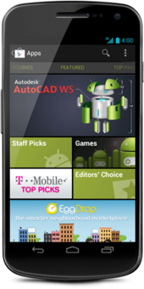

Figure .3 An Android Device

Android is a mobile phone operating system. It was originally developed by Android Inc, which was acquired by Google in July 2005. Today, development is overseen by the Android Open Source Project (AOSP), led by Google. The AOSP is “tasked with the maintenance and further development of Android”.

As of the 3rd Quarter of 2010 Android has a market share of 25% making it the second most popular phone operating system of the market (second only to Nokia’s Symbian). This is a major rise from the 3.5% share Android had in 3Q2009.

Android, Inc. was founded in Palo Alto, California, United States in October 2003 by Andy Rubin (co-founder of Danger), Rich Miner (co-founder of Wildfire Communications, Inc.), Nick Sears (once VP at T-Mobile),and Chris White (headed design and interface development at WebTV)to develop, in Rubin's words "...smarter mobile devices that are more aware of its owner's location and preferences. Despite the obvious past accomplishments of the founders and early employees, Android Inc. operated secretly, revealing only that it was working on software for mobile phones. That same year, Rubin ran out of money. Steve Perlman, a close friend of Rubin, brought him $10,000 in cash in an envelope and refused a stake in the company.

Google acquired Android Inc. on August 17, 2005, making Android Inc. a wholly owned subsidiary of Google. Key employees of Android Inc., including Andy Rubin, Rich Miner and Chris White, stayed at the company after the acquisition .

* 1. **Features**

World is contracting with the growth of mobile phone technology. As the number of users is 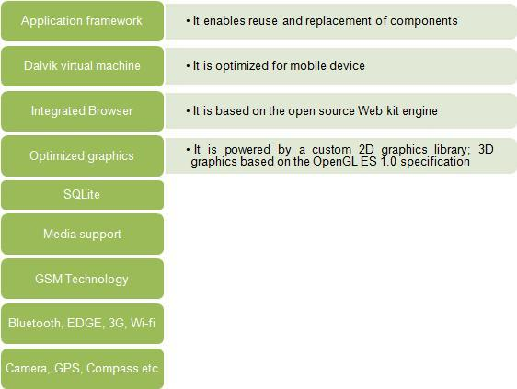

Figure 1.4 Android OS Features

increasing day by day, facilities are also increasing. Starting with simple regular handsets which were used just for making phone calls, mobiles have changed our lives and have become part of it. Now they are not used just for making calls but they have innumerable uses and can be used as a Camera , Music player, Tablet PC, T.V. , Web browser etc . And with the new technologies, new software and operating systems are required.

Today Android is very popular among the user. Today the mobiles are not only thought to be used in the just for communication but is a mini computer which has the computing and manipulating capacity as that of computers. The wide use and popularity of the android is due to the various features available in it.

* + 1. **Application Framework**

It is used to write application for Android .Unlike other embedded mobile environment ,Android application are all equal, for instance ,an application which come with the phone are no different then those that any developer writes. The framework is supported by numerous open source libraries such as openssl,SQLite and libc. It is also supported by the android core libraries. From the point of security, the framework is based on UNIX file system permission that assure application have only those abilities that mobile phone owner gave taem at install time.

**1.4.2 Dalvik Virtual Machine**

It is extremely low memory based virtual machine,which was designed especially for Android to run on embedded systems and work well in low power situations. It is also tuned to CPU attributes .The Dalvik VM creates a special file format (.DEX ) that is created through build time post processing.Conversion between Java classes and .DEX is done by included “dx” tool

**1.4.3 Integrated Browser**

Google made a choice on WebKit as open source web browser. They added a two pass layout and frame flattening . Two pass layout loads a page without waiting for blocking elements such as external CSS or Javascript.

**1.4.4 Optimized Graphics**

An Android has 2D graphics library and 3D graphics based on OpenGL ES 1.0.

* + 1. **SQLite**

SQLite is ACID-compliant and implements most of the SQL standard, using a dynamically and weakly typed SQL syntax that does not guarantee the domain integrity.

SQLite is a popular choice as embedded database for local/client storage in application software such as web browsers. It is arguably the most widely deployed database engine, as it is used today by several widespread browsers, operating systems, and embedded systems, among others.SQLite has many bindings to programming languages.

* + 1. **Java Virtual Machine**

virtual machine (JVM) is a virtual machine that can execute Java bytecode. It is the code execution component of the Java software platform. Sun Microsystems has stated that there are over 5.5 billion JVM-enabled devices.

A Java virtual machine is a program which executes certain other programs, namely those containing Java bytecode instructions. JVMs are most often implemented to run on an existing operating system, but can also be implemented to run directly on hardware

* + 1. **Development Environment**

Includes a device emulator , tools for debugging ,memory and performance profiling, a plugin for the eclipse IDE. There are a number of hardware dependent features, for instance , a huge media and connections support, GPS, GSM telephony. A great work was done for the developers to start work with Android using device emulator ,tools for debugging and plugins for eclipse.

The different version of the android operating system that are launched are listed here

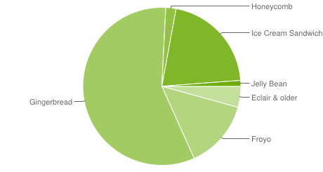

Figure 1.4.7 Different versions of android OS

Table Different versions of android OS

| **Version** | **Release date** | [**API**](http://en.wikipedia.org/wiki/Application_programming_interface)**level** | **Distribution (September 4, 2012)** |
| --- | --- | --- | --- |
| 4.1.x *Jelly Bean* | July 9, 2012 | 16 | 1.2% |
| 4.0.x *Ice Cream Sandwich* | October 19, 2011 | 14-15 | 20.9% |
| 3.x.x *Honeycomb* | February 22, 2011 | 11-13 | 2.1% |
| 2.3.x *Gingerbread* | December 6, 2010 | 9-10 | 57.5% |
| 2.2 *Froyo* | May 20, 2010 | 8 | 14% |
| 2.0, 2.1 *Eclair* | October 26, 2009 | 7 | 3.7% |
| 1.6 *Donut* | September 15, 2009 | 4 | 0.4% |
| 1.5 *Cupcake* | April 30, 2009 | 3 | 0.2% |

* 1. **Architecture**

Android is based on the Linux Kernel. Android Developers are able to access all the componements of the Application Framework used by core applications when creating an application.

**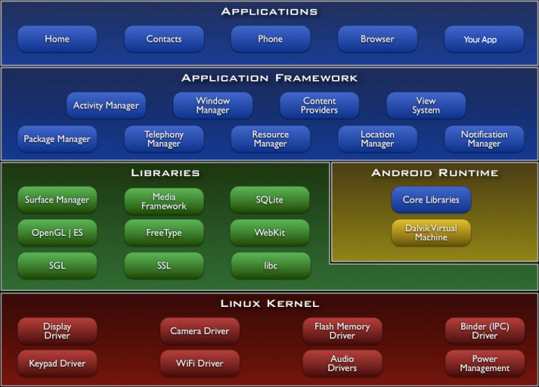**

Figure 1.5 Android OS architecture

The above figure shows the diagram of Android Architecture. The Android OS can be referred to as a software stack of different layers, where each layer is a group of sveral  program components. Together it includes operating system, middleware and important applications. Each layer in the architecture provides different services to the layer just above it.

* 1. **OBJECTIVES**

One of the most widely used mobile OS these days is ANDROID. Android is a software bunch comprising not only operating system but also middleware and key applications.

So a s a Minor Project in Bachelor in Computer Engineering, our team with three members has selected the project entitled “Restaurant Guide – A GPS based Android App”.This application includes the features of google api to mark the present location of the individual and displays the nearest list of some restaurant .This application even displays the menu available in the restaurant there and choice their place according to their requirement.

The application includes

* Database and Query handling with overall GUI design
* Geo-code specific Google maps and other related features design
* Optimum path finding and route highlighting with other related features design
* User Account Handling and Food Ordering Management

The basic objectives of this projects are:

* To understand and realize the real world project , understand the problems associated in developing it and explore the appropriate solution to it.
* To understand the application development in android based system.
* To be familiar with the google maps api and understand the features available on it.
* To think in a way so as to make the life simpler and easier with the available technology and resources.
* Finally working in a group with cooperation in team members with respect .

The specific objectives are:

* To facilitate the user of android to get the nearby location of the hotel through this app.
* To order the required items from the nearby hotel by sending emails.
* To view the path to the hotel through the map
* It facilitates the new user to the valley to guide them to the partocular destination hotel through the path provided.
  1. **Outline of the Report**

The Report is organized in to five chapters.

* The first chapters discuss about the introduction of Android, history, features and architecture.
* The second chapter is about the methodology, implementation details of our work, theoretical description.
* The third chapter is the Result and Analysis along with output.
* Fourth chapter is about limitation and conclusion .

1. **IMPLEMENTATION**
   1. **Requirement Analysis**

Requirement analysis is the first thing to be done in starting any kind of project. Requirement analysis is important and preliminary factor of software development process. It helps to identify the feasibility of project and many more.

Hence in order to make our project real project and to realize the project in a practical way, we first analyze the requirement of our project. Specifically the requirements of our project are tabulated as:

* Identify the Current location of user,
* List out the nearest Hotel on the basis of distance,
* User should be able to order the items from the hotel.
* User should be guided to the hotel through the map and route the path.
  1. **Methodology And Tools**

Java is used as programming language to implement and test the application. In this projects of GPS based android system ,we have used the java programming language and the IDE used is the ECLIPSE.

Before starting the android programming in Eclipse, We need the components like JDK, Android software development kit (SDK), Android Development Tools (ADT) plugin for Eclipse.

The Android software development kit (SDK) includes a comprehensive set of development tools. These include a debugger, libraries, a handset emulator based on QEMU, documentation, sample code, and tutorials. The officially supported integrated development environment (IDE) is Eclipse using the Android Development Tools (ADT) Plugin, though IntelliJ IDEA IDE (all editions) fully supports Android development out of the box, and NetBeans IDE also supports Android development via a plugin. Also SDK provides several interface and drag and drop features in it. We have used several features available in it as per our need and the requirement.

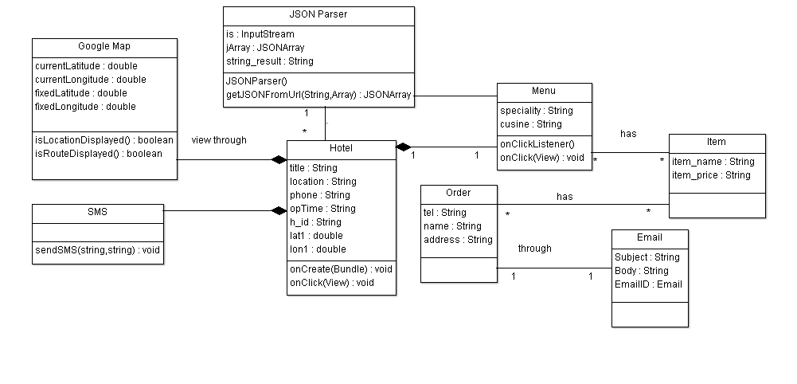

Figure 2.2a A class diagram showing overall application overview

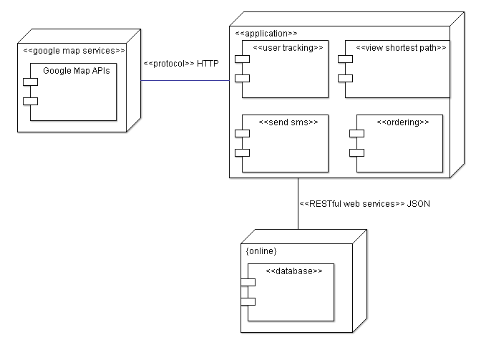

Figure 2.2b A deployment diagram for the application

* 1. **Background Theories**
     1. **Maps, Geocoding and Location Based Services**

One of the defining features of mobile phones is their portability, so it’s not surprising that someof the most enticing Android features are the services that let us find, contextualize, and map physical locations.

We can create map-based Activities using Google Maps as a User Interface element. We have full access to the map, allowing us to control display settings, alter the zoom level, and move the centered location. In order to display the map in the application ,we can use API provided. There are several API,s related . However Google Maps API is very popular and are extensively used. Google API has the several features available in it which we can use it through simple effort and in an easier way. For this purpose of using Google map API in our application we need to generate the MD5 hash key through the command line and send it to the Google Incs which inturn provides the API key. This API key is used in the application to display the map.

Google maps has its own symbols and patterns . We may come across the situation that we need to add some markers and symbols on the map. In that situation Goole API provides a tool named Overlay. Using Overlays, within the project ,we can annotate maps and handle user input to provide map contextualized information and functionality. We can use any no of overlays on the map according to the need and specification. Overlays are a way to add annotations and click handling to MapViews. Each Overlay lets you draw 2D primitives including text, lines, images and shapes directly onto a canvas, which is then overlaid onto a Map View.We can add several Overlays onto a single map. All the Overlays assigned to a Map View are added as layers, with newer layers potentially obscuring older ones. User clicks are passed through the stack until they are either handled by an Overlay or registered as a click on the Map View itself.

Location-Based Services (LBS) — the services that let us find the device’s current location. They include technologies like GPS and Google’s cell-based location technology. We can specify which location-sensing technology to use explicitly by name, or implicitly by defining a set of criteria in terms of accuracy, cost, and other requirements. Google map API has the in built library through which we can find the device current location .Further it has the ability to listen the location change of the device. Whenever the location of the device is changed from a particular location, it provides the notification of location changed through the features available in it. Location-based services (LBS) is an umbrella term used to describe the different technologies used to findthe device’s current location. The two main LBS elements are:

* LocationManager Provides hooks to the location-based services.
* LocationProviders Each of which represents a different location-finding technology used to determine the device’s current location.

Using the Location Manager, we can:

* Obtain your current location.
* Track movement.
* Set proximity alerts for detecting movement into and out of a specifi ed area.

Maps and location-based services use latitude and longitude to pinpoint geographic locations,

but users are more likely to think in terms of an address. Android provides a Geocoder that

supports forward and reverse geocoding. Using the Geocoder, We can convert back and forth

between latitude/longitude values and real-world addresses. Forward Geocoding is the conversion of address provided in to the latitude and longitude whereas Reverse Geocoding is the conversion latitude and longitude in to the address.

Used together, the mapping, geocoding, and location-based services provide a powerful toolkit for incorporating phone’s native mobility into mobile applications.

* + 1. **Data Storage , Retrieval and Sharing**

Data are the major part in every project /application in the android. Several data are to be stored and retrieved according to the need. Android has also the data storage and retrieval features available in it. SQLite is the default database provided by the android , However it is not compulsory to use the SQLite database .We can use other database like mysql and other database too according to our need and requirement.

* + - 1. **SQLite Database**

Android provides full relational database capabilities through the SQLite library, without imposing any additional limitations.

Using SQLite, We can create independent, relational databases for each application. Use them to store and manage complex, structured application data. All Android databases are stored in the /data/data/<package\_name>/databases folder on our device (or emulator). By default, all databases are private, accessible only by the application that created them.

. In particular, when creating databases for resource-constrained devices, it’s important to reduce data redundancy using normalization.

SQLite is a relational database management system (RDBMS). It is well regarded, being:

* Open source
* Standards-compliant
* Lightweight
* Single-tier

It has been implemented as a compact C library that’s included as part of the Android software stack.

By providing functionality through a library, rather than as a separate process, each database becomes an integrated part of the application that created it. This reduces external dependencies, minimizes latency, and simplifies transaction locking and synchronization.

SQLite has a reputation of being extremely reliable and is the database system of choice for many consumer electronic devices, including several MP3 players, the iPhone, and the iPod Touch. Lightweight and powerful, SQLite differs from many conventional database engines by using a loosely typed approach to column definitions. Rather than requiring column values to conform to a single type ,the values in each row for each column are individually typed. As a result, there’s no strict type checking when assigning or extracting values from each column within a row.

**2.3.2.1. MySQL Database**

MySQL is primarily an RDBMS and ships with no GUI tools to administer MySQL databases or manage data contained within the databases. Users may use the included command line tools, or use MySQL "front-ends", desktop software and web applications that create and manage MySQL databases, build database structures, back up data, inspect status, and work with data records. The official set of MySQL front-end tools, MySQL Workbench is actively developed by Oracle, and is freely available for use.

**2.3.2.2. JavaScript Object Notation**

JSON (JavaScript Object Notation) is a text-based open standard designed for human readable independent data interchange. JSON is limited to text and numeric values. Binary values are not supported. JSON is a subset of the JavaScript Specification (ECME-Script) and it is therefore directly supported in JavaScript. Data structures in JSON are based on key / value pairs. The key is a string, the value can be a numerical value, a boolean value (true or false) or an object.

The JSON format is often used for serializing and transmitting structured data over a network connection. It is used primarily to transmit data between a server and web application, serving as an alternative to XML.

**2.3.2.2.1 JSON Data Types and Syntax**

JSON's basic types are:

* Number (double precision floating-point format in JavaScript, generally depends on implementation)
* String (double-quoted Unicode, with backslash escaping)
* Boolean (true or false)
* Array (an ordered sequence of values, comma-separated and enclosed in square brackets; the values do not need to be of the same type)
* Object (an unordered collection of **key:value** pairs with the ':' character separating the key and the value, comma-separated and enclosed in curly braces; the keys must be strings and should be distinct from each other)
* null (empty)

An JSON object is a set of key / value pairs which starts with "{" and ends with "}".

{

{

firstName:'Lars',

lastName:'Vogel',

address: {

street:'Examplestr.',

number: '31'

}

}

JSON arrays are one or more values surrounded by [] and separated by ",".

[

{

firstName:'Lars',

lastName:'Vogel',

address: {

street:'Examplestr.',

number: '31'

}

}

,

{

firstName:'Jack',

lastName:'Hack',

address: {

street:'Examplestr.',

number: '31'

}

}

]

**2.3.2.2.2 Parsing through RESTful Services and JSON Responses**

Roy Fielding’s explanation of the meaning of REST was "Representational State

Transfer ” is intended to evoke an image of how a well-designed Web application

behaves: a network of web pages (a virtual state-machine), where the user progresses

through an application by selecting links (state transitions), resulting in the next page

(representing the next state of the application) being transferred to the user and rendered

for their use." It is for creating large scale of network system architecture style.

Motivation of REST was to create an architectural model how the Web service should

work, such that it could serve as the guiding framework for the Web protocol’s

standards. REST has been applied to describe the desired Web architecture, helped to

identify existing problems, to compare alternative solutions, and ensure that protocol

extensions would not violate the core constraints that make the Web successful.

. But standards are usable even though REST is not a standard. For example:

* HTTP
* URL
* XML/JSON/HTML /etc
* Text/xml, object/json, text/html, etc

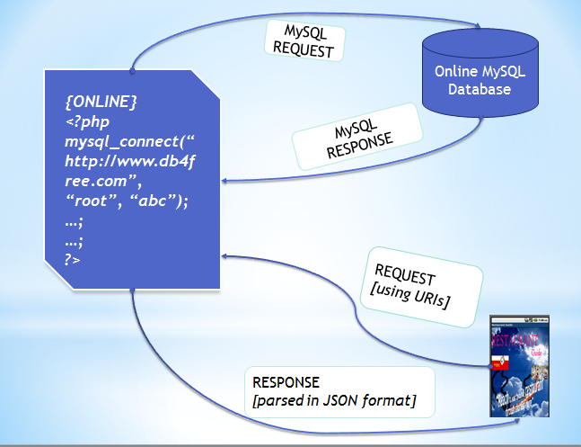

Figure 2.3.2.2.2 Relationships between JSON, PHP and Mysql database

* + 1. **Haversine Formula : Distance Between Two Geocodes**

The **haversine formula** is an equation important in navigation, giving great-circle distances between two points on a sphere from their longitudes and latitudes. It is a special case of a more general formula in spherical trigonometry, the **law of haversines**, relating the sides and angles of spherical "triangles".

These names follow from the fact that they are customarily written in terms of the haversine function, given by haversin(θ) = sin2(θ/2). The formulas could equally be written in terms of any multiple of the haversine, such as the older versine function (twice the haversine). Historically, the haversine had, perhaps, a slight advantage in that its maximum is one, so that logarithmic tables of its values could end at zero. These days, the haversine form is also convenient in that it has no coefficient in front of the sin2 function.

For any two points on a sphere, the haversine of the central angle between them is given by

\operatorname{haversin}\left(\frac{d}{r}\right) = \operatorname{haversin}(\phi_2 - \phi_1) + \cos(\phi_1) \cos(\phi_2)\operatorname{haversin}(\lambda_2-\lambda_1)

where

* *haversin* is the haversine function:

\operatorname{haversin}(\theta)=\sin^2\left(\frac{\theta}{2}\right)=\frac{1-\cos(\theta)}{2}

* *d* is the distance between the two points *r* is the radius of the sphere,
* \phi_1, \phi_2: latitude of point 1 and latitude of point 2
* \lambda_1, \lambda_2: longitude of point 1 and longitude of point 2

On the left side of the equals sign d/r is the central angle, assuming angles are measured in in radians. Solving for *d,* by applying the inverse haversine (if available) or by using the arcsine (inverse sine) function:

d = r  \operatorname{haversin}^{-1}(h) = 2 r \arcsin\left(\sqrt{h}\right)

where *h* is haversin(*d*/*r*), or more explicitly:

d = 2 r \arcsin\left(\sqrt{\operatorname{haversin}(\phi_2 - \phi_1) + \cos(\phi_1) \cos(\phi_2)\operatorname{haversin}(\lambda_2-\lambda_1)}\right)

 = 2 r \arcsin\left(\sqrt{\sin^2\left(\frac{\phi_2 - \phi_1}{2}\right) + \cos(\phi_1) \cos(\phi_2)\sin^2\left(\frac{\lambda_2 - \lambda_1}{2}\right)}\right)

This formula is only an approximation when applied to the Earth, which is not a perfect sphere: the "Earth radius" *R* varies from 6356.78 km at the poles to 6378.14 km at the equator. More importantly, the radius of curvature of a north-south line on the earth's surface is 1 per cent greater at the poles than at the equator— so the haversine formula and law of cosines can't be guaranteed correct to better than 0.5 per cent.

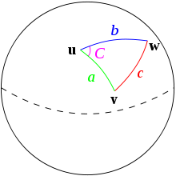

Figure 2.3.3 A sphere showing three geopoints

Given a unit sphere, a "triangle" on the surface of the sphere is defined by the great circles connecting three points **u**, **v**, and **w** on the sphere. If the lengths of these three sides are *a* (from **u** to **v**), *b* (from **u** to **w**), and *c* (from **v** to **w**), and the angle of the corner opposite *c* is *C*, then the law of haversines states:

\operatorname{haversin}(c) = \operatorname{haversin}(a - b) + \sin(a) \sin(b) \, \operatorname{haversin}(C).

1. **RESULT AND ANALYSIS**

The application thus developed has the following results:

* 1. **Geo-code Specific Google Maps and Other Related Features Design**

**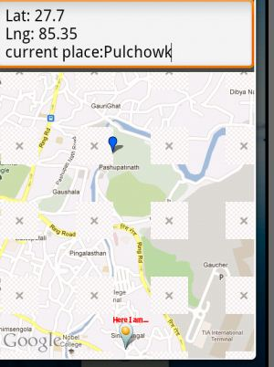**

The application starts with the current geo location of the user. The current location of the user is marked by the overlay items . When the user changes the location ,this change in location is listened by the application and current location is updated with the update in location of user.

* 1. **Database and Query Handling with Overall GUI Design**

**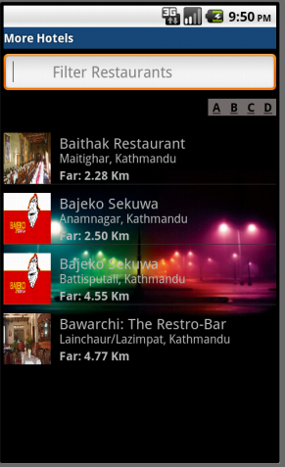**

Figure 3.2a app displaying the hotel list

**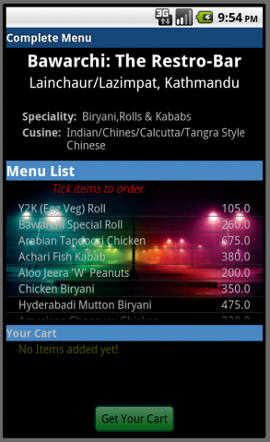**

Figure 3.2b app displaying the menu

After finding the current location of the user, this application shows the list of the available hotels in the database. The of database is displayed on the ascending order of nearest hotels to that of user which are within 3KM from the current location. From the available hotels in the list ,user can select any hotel and get the details of the hotel. User can also make order of the food and items available in the hotel through the email.

* 1. **Optimum Path Finding and Route Highlighting**

**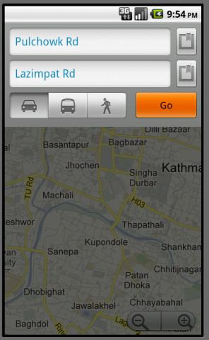**

Figure 3.3a currentand destination place in map

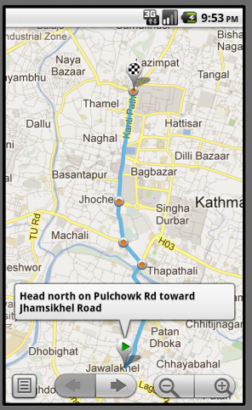

Figure 3.3b path from current to destination place in map

Google map API is used in the application. This API shows the optimum path to the destination hotel selected by the user. When the user selects the hotel , the detail of

the hotel is available to the user . Apart from this , ‘View map ’ button is made available at the end of the screen ,which on click shows the route between the current location and destination location.

* 1. **Message Communication**

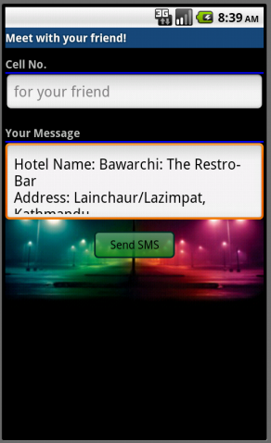

Figure 3.5 message sending part

This application has the features of message communication between user. When the user wants to meet the friend in hotel ,then he can send the message to the another user giving the hotel name ,address and telephone.

1. **LIMITATIONS AND CONCLUSION**

As far as we could, we tried our best to make the application perfect and real application. Even though there are some limitations that we were unable to implement in the application despite of our effort. We could not implement the online payment to the hotels. Also the hotels cannot check the remaining balance of the user when the user makes order for the items available in the hotels. We could not include several hotels/restaurants in our database located in the valley.

Further we have no login facilities to the user. And user can order only the 1 item at a time,which we will enhance in the near future.

1. **FURTHER ENHANCEMENT**

As we have some of the limitation in our application, we can enhance our application in it.

We can enhance the application to add more and more hotels and restaurant available within the valley. Furthermore we need to make our application check the available balance of the user. We should deny the request of the delivery to the user if the balance is below the certain balance. In the upcoming days we also can enhance this application in the area of Google Map API . The Google map shows only one path between the user and destination. We can show more than one path with their distance so that user can select any route which can be easy for them.

**REFERNCES**

1. Reto Meier, “Professional Android Application Development”, Wiley Publishing Inc., Indianapolis, Indiana, 2009.
2. Google Inc., "Using JSON with Google Data APIs", July 3, 2009.
3. Crockford, Douglas, "Introducing JSON”, May 28, 2009.
4. JSON in Java , <http://www.json.org>.
5. Mark Murphy , “The Busy Coder's Guide to Android Development “ Commons Ware,2009.